**Introduction to UX Design Assignment 1**

**Heuristic evaluation of Google Travel website**

Usability Heuristics for User Interface design

1. **Visibility of system status**: The website conveys status of the system well. Doesn’t keep the user in dark and engages the user with appropriate content. Even the choices for hotels and flights on map is updated dynamically as per selection, keeping the users well informed.

However, some updates related to delays are displayed selectively at corners, which not very conspicuous.

1. **Match between system and the real world:** The site presents the information pretty organized and is easy to comprehend. Icons are put to effective use, making it simple to understand.
2. **User control and freedom:** There is enough control and freedom from a user’s perspective. All the user selections could be undone easily. There is scope for cancellations till the payment is made. This would reduce erroneous user activity. The presence of a feedback option also makes it easier for a user to contribute suggestions.

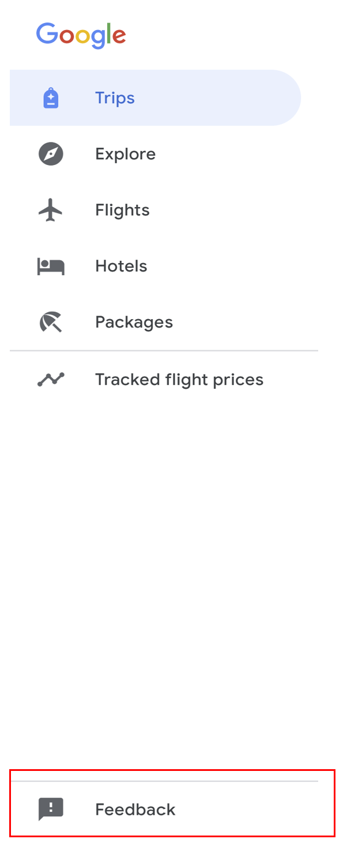

1. **Consistency and standards:** I feel the site is consistent internally. However, when looking for external consistency with other Google products like Google News, Google translate, etc, there are gaps. The menu bar on top right corner for example opens up different menu options for different products.

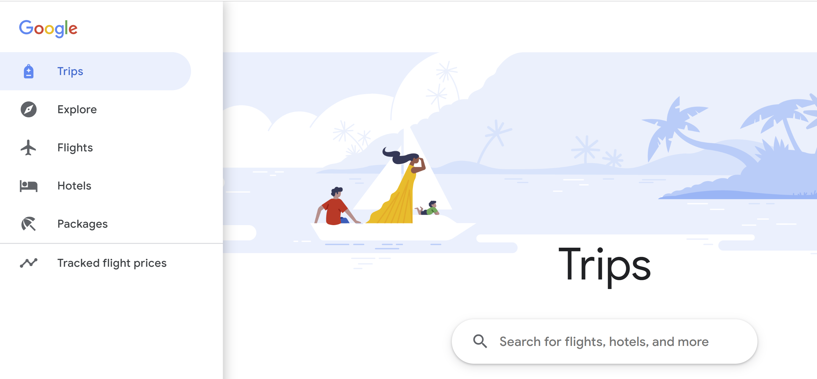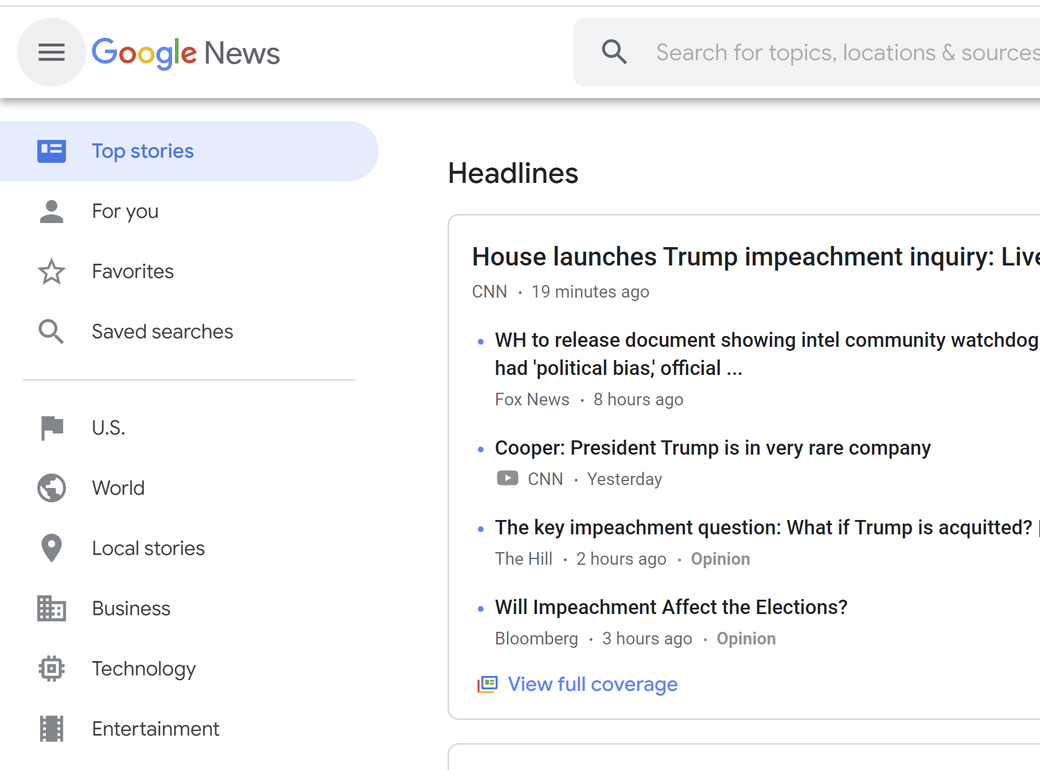

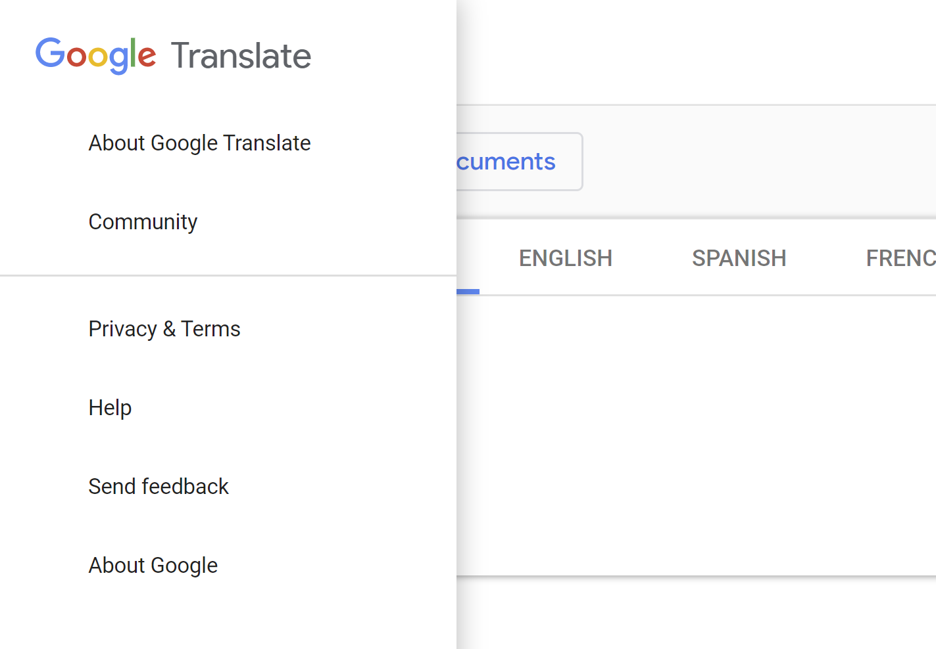

1. **Error prevention:** Excellent job in error prevention. There is hardly any chance for the user to perform errors. The payment methods have sufficient precautions to prevent wrong payments too.
2. **Recognition rather than recall:** Few options are presented well so that the user doesn’t have to recall. However, I feel a better job could be done in terms of visual cues. For example, a green tick mark could be placed on the completed trips. This way, even when a user doesn’t have the time to read the text, the tick mark would convey the message.

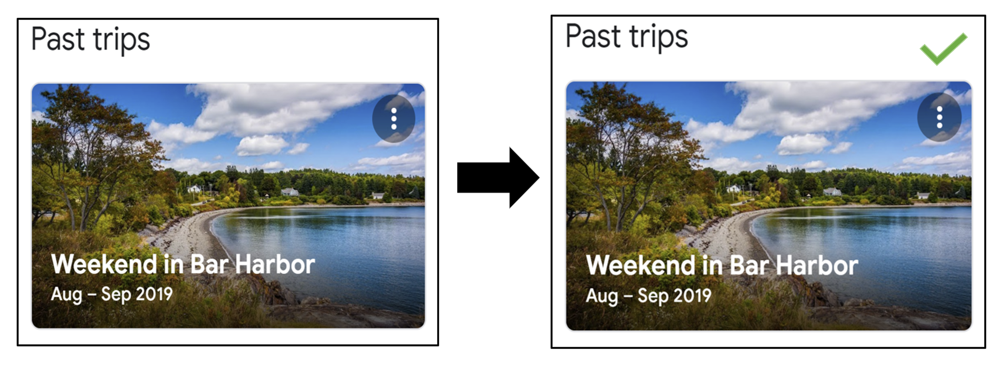

Similarly, icons could be used to indicate upcoming trips like the ones pasted below.

  

Upcoming Saved Saved

1. **Flexibility and ease of use:** Wonderful design in terms of flexibility and ease of use. Google Travel offers suggestions for flights, hotels, places to visit, things to do, etc. This creates an experience of “everything under one roof” and eases the users into planning their trips.
2. **Aesthetic and minimalist design:** The design of the home page is aesthetic, but not minimal. It could be made better by excluding repetitive menu options.

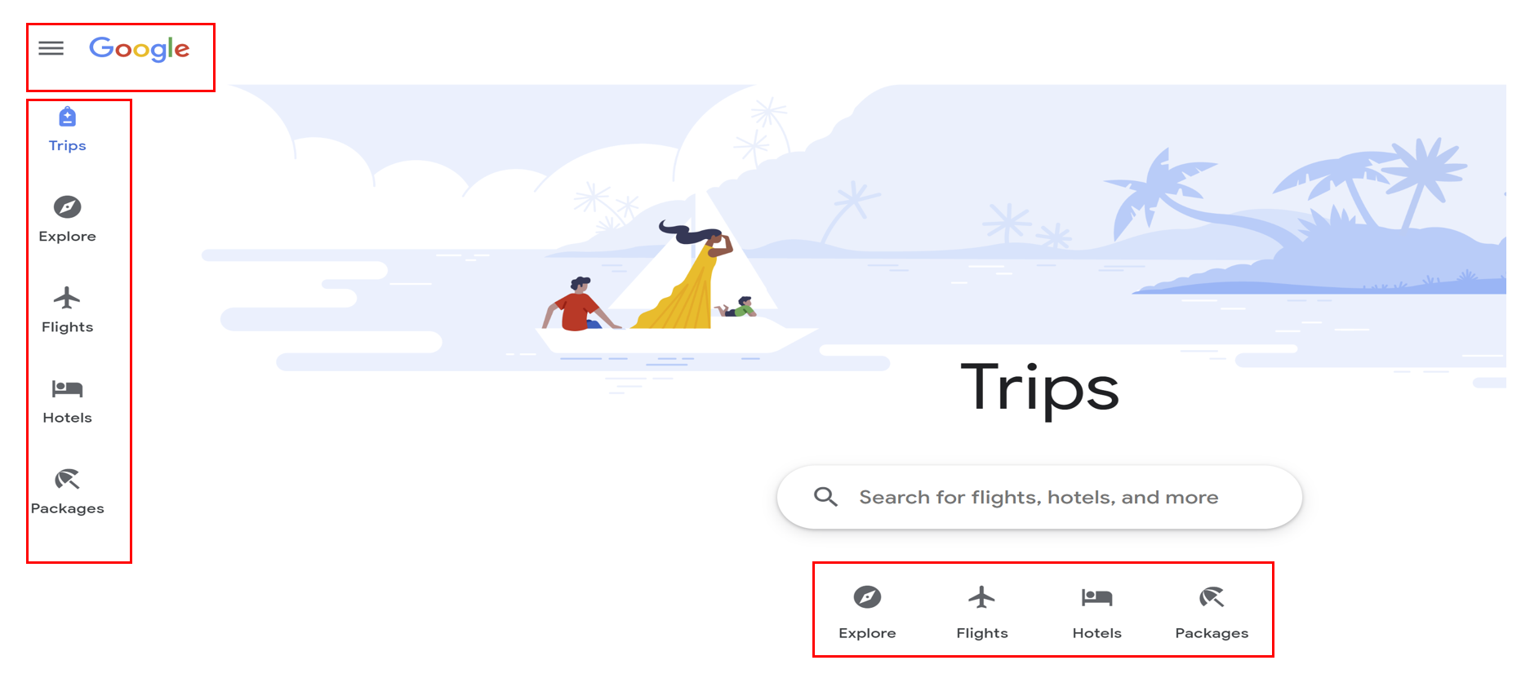

1. **Help users recognize, diagnose and recover from errors:** Website is wonderfully designed to prevent errors. There is very less possibility that a user would end up in an incorrect action.
2. **Help and documentation:** Not available. It could have been helpful if there was guidance on how to use the website or how to get started in planning a trip.

Thank You

Pradeepti